CHILD’S HILL ALLOTMENTS CULTIVATION GUIDE
What is cultivation?
Walk up and down the paths and you’ll see some examples of beautifully tended plots bursting with fruit, veg and flowers – with barely a weed in sight. However, we were recently asked “what is non-cultivation?” It is one of those things that you know it when you see it – but is tricky to define. So, we did some research to find out how other sites define it. We’ve taken the best of their ideas to come up with these guidelines for plot holders and committee members at Child’s Hill Allotments.

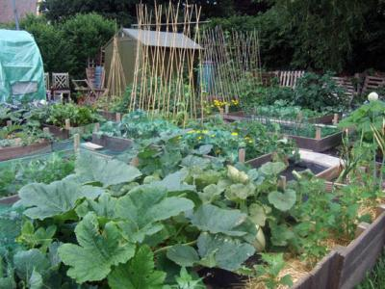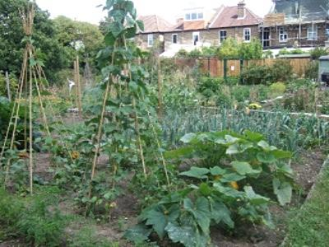
This is what we would expect …
In order to be fair to other tenants, we would expect the plot to be cultivated in a way that does not interfere with the enjoyment of neighbouring plot holders or sabotage their efforts to keep a weed-free plot.
The plot needs to be planted, cropped, harvested or being prepared. It is not sufficient to simply keep the plot clear of weeds, but to leave it un-planted.
In the main growing season we would expect to see:
- Fruit, vegetables or flowers
- Lawn and grass paths mowed and trimmed
- No weeds going to seed
- No brambles or couch grass creeping around the plot
In the winter months:
- The above (but obviously fewer fruit, veg and flowers)
- Beds dug over ready for the winter frost
- Green manures being grown
- Growing areas being prepared (and covered to suppress weeds)
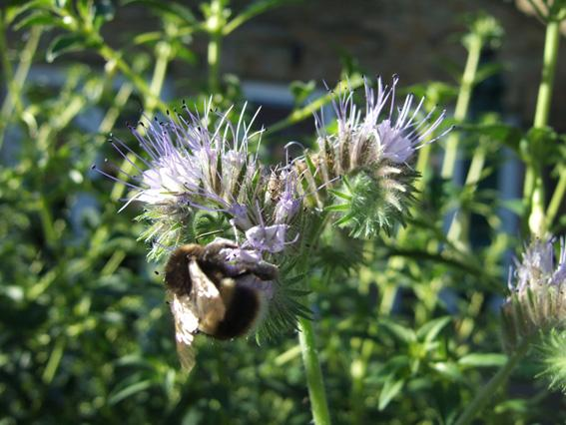

Cultivation area
New tenants usually take on a mess of overgrown weeds. After a long time on the waiting list we assume you are raring to go. So it is not unreasonable to expect a new tenant to have at least 50% of their plot cultivated in their first three months on site.
We would then expect up to 80% of their plot cultivated after 6 months of taking tenancy. By 12 months we would expect 100% cultivation.
Around 20% of the plot can be occupied by temporary structures (that is a shed, fruit cage, polytunnel, greenhouse). Please note that a shed may not occupy more than 5% of the total area of your plot, and you must ask permission from the committee before you erect one.
Site inspections
Site inspections are carried out on a regular basis – at least every two months in the growing season -- by members of the committee. If a neighbour complains we will inspect within a week.
Initially we look at the entire plot to see that the majority of the plot is being cultivated and cropped. We will note if large areas have been left unworked.
Next, we look at the level of weed growth on the plot. Everyone has a few weeds sprouting on their plot. We are concerned with weeds going to seed in large areas of the plot and causing a nuisance to neighbouring plots.
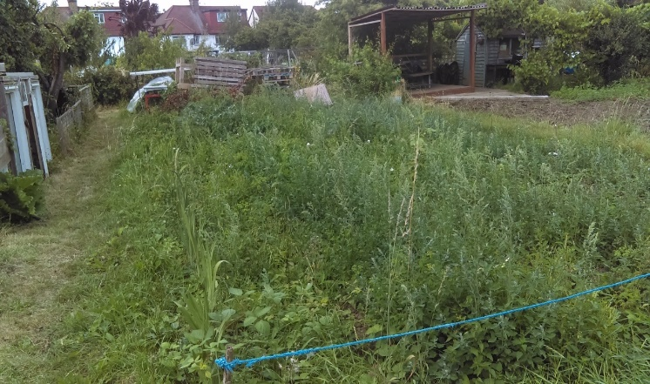
How tall are your weeds? Are they going to seed and out of control?
We also look at uncontrolled areas of perennial weeds such as couch grass, ground elder, brambles, nettles and unmanaged grass.
We are gardeners too so we take the season into account. At mid-summer, most of the plot should be used for growing fruit, veg or flowers. Plots mostly covered by, for instance, plastic sheeting, are not considered to be cultivated.
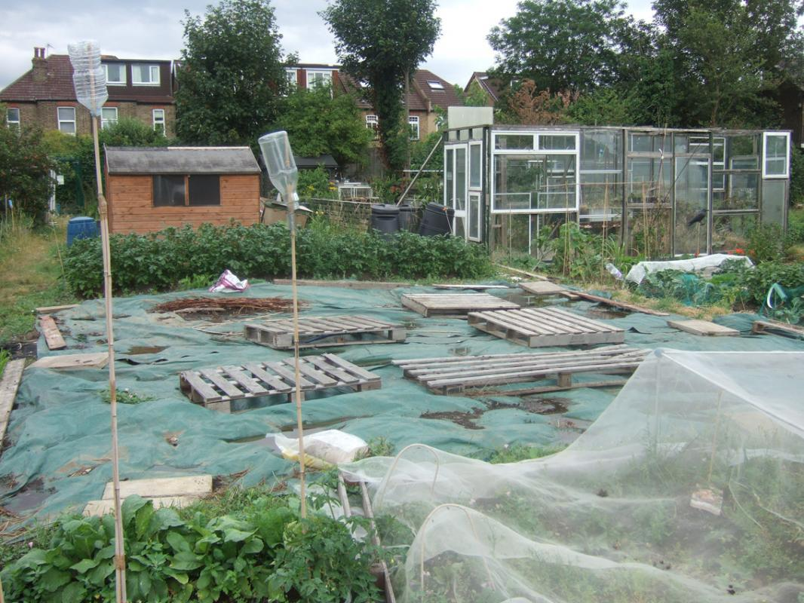
Is your plot covered in summer when it should be cultivated?

During the autumn and winter months, we will be looking to see that plots which have become weedy in the late summer are being cleared and improved. However, this does not mean you need to be sowing crops. Generally if you are using the winter months to improve your plot then this will be taken into account.
We will also look at the level of waste on the plot, in particular if new waste materials have been brought onto the site. Plot holders like to recycle and find it hard to pass a skip. But those recycled materials need to be used not just stored indefinitely.
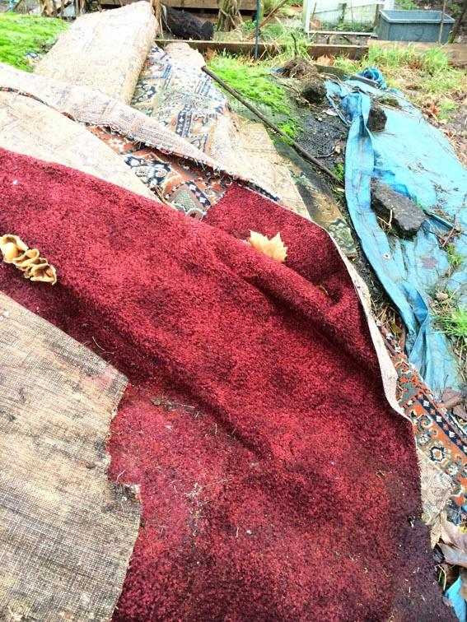
Carpet is expensive to remove - please do not bring it on site.
Materials such as carpet, double glazing, timber, doors, tyres and building or landscaping materials are of particular concern – because they are expensive to remove – so please do not bring them. Each time we hire a skip it costs us £300.
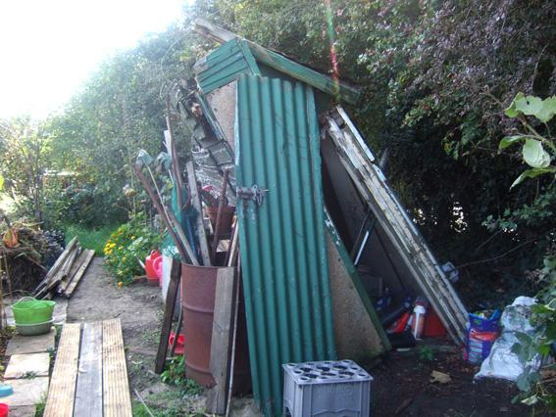
Sheds should be fit for purpose and not in a dangerous condition.
Photos of the plot are then taken as a record of what was observed and we complete a form that covers the above points in case there is a dispute and you disagree with our findings.
Mitigating circumstances
We do realise you have a life outside the allotment and there may be reasons for not cultivating an allotment plot for a temporary period of time which might include:
- Hospitalisation for surgery or other serious complaints
- Short-term medical complaint where advice has been given by a medical practitioner that physical work is not advisable
- Death of a close family member
However, the committee would expect the plot holder to ensure all long vegetation on the plot is kept down so that other allotment holders are not affected by weeds. If you contact us, we can put you in touch with people who can strim your plot for a fee.
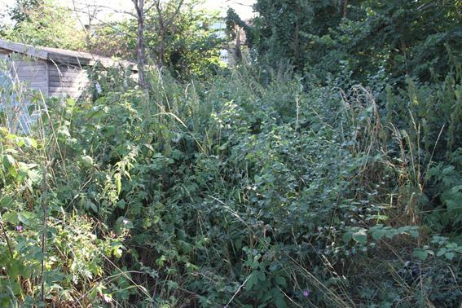
If you are having problems and falling behind. Please talk to us. We will do our best to help and advise.
Absentee gardening
Absentee gardeners are those who, generally on receipt of a non-cultivation letter, pay someone to dig over and weed the plot, hoping that this will get them off the hook for the season. They go from one non-cultivation letter to the next, using them as reminders to visit the plot.
There’s nothing wrong with getting a little help from family and friends, but the committee expects that the plot holder will be in attendance and will be the main contributor to the allotment, otherwise it will be assumed that the plot holder has neither the time nor interest to maintain the allotment and the tenancy will be cancelled.
Allotments are community ventures in which everyone is expected to play a part, not least in occasionally helping with the maintenance of the site on volunteer days. Absentee gardeners play no part in the community and cause ill-feeling as well as failing to reap the benefits of having an allotment.
Why does non-cultivation matter?
Non-cultivation matters because when you took on your plot you agreed to cultivate.
When we signed the Lease with the landlord, Barnet Council, we all agreed:
4. Allotments are to be wholly or mainly cultivated by the tenant for the production of vegetables or fruit crops for consumption by the occupier and his/her family.
14. Tenants must keep their allotments reasonably free from weeds and rubbish, and otherwise maintain them in a proper state of cultivation to the satisfaction of the society.
You need to be a good neighbour. Your weed seeds don't just affect your plot, they are a nuisance to us all. So, in order to be fair to other tenants, we would expect the plot to be cultivated in a way that does not interfere with the enjoyment of neighbouring plot holders or sabotage their efforts to keep a weed-free plot.
The future of this place. Look around the site and you will see houses, and there are plans to build more houses on all open spaces surrounding the allotment site. Land is always at a premium in London. Under the terms of our Lease with London Borough of Barnet, if the allotment site is not fully cultivated, they have a right to reclaim it. One of the best ways of ensuring that this does not happen is for all of us to cultivate our plots. Our allotments’ future is in our hands!
Child’s Hill Allotment Society Committee

